Assignment2
Xinying(Ashlyn) Li
Trinity College

Ping Test

Test 1: 10 times from lab machine to Raspberry Pi

PING 192.168.10.2 (192.168.10.2) 56(84) bytes of data.
64 bytes from 192.168.10.2: icmp_seq=1 ttl=64 time=0.422 ms
64 bytes from 192.168.10.2: icmp_seq=2 ttl=64 time=0.477 ms
64 bytes from 192.168.10.2: icmp_seq=3 ttl=64 time=0.488 ms
64 bytes from 192.168.10.2: icmp_seq=4 ttl=64 time=0.482 ms
64 bytes from 192.168.10.2: icmp_seq=5 ttl=64 time=0.488 ms
64 bytes from 192.168.10.2: icmp_seq=6 ttl=64 time=0.480 ms
64 bytes from 192.168.10.2: icmp_seq=7 ttl=64 time=0.475 ms
64 bytes from 192.168.10.2: icmp_seq=8 ttl=64 time=0.480 ms
64 bytes from 192.168.10.2: icmp_seq=9 ttl=64 time=0.532 ms
64 bytes from 192.168.10.2: icmp_seq=10 ttl=64 time=0.490 ms

--- 192.168.10.2 ping statistics ---
10 packets transmitted, 10 received, 0% packet loss, time 1835ms
rtt min/avg/max/mdev = 0.422/0.481/0.532/0.025 ms

For the test from the lab machine to the Raspberry Pi, the mean is 0.481ms with a standard deviation of 0.025ms. This means the testing data is quite closely packed together, since the standard deviation is quite small.

Test 2: 10 times from the Raspberry Pi to the lab machine

PING 192.168.10.1 (192.168.10.1) 56(84) bytes of data.
64 bytes from 192.168.10.1: icmp_seq=1 ttl=64 time=0.657 ms
64 bytes from 192.168.10.1: icmp_seq=2 ttl=64 time=0.392 ms
64 bytes from 192.168.10.1: icmp_seq=3 ttl=64 time=0.568 ms
64 bytes from 192.168.10.1: icmp_seq=4 ttl=64 time=0.541 ms
64 bytes from 192.168.10.1: icmp_seq=5 ttl=64 time=0.577 ms
64 bytes from 192.168.10.1: icmp_seq=6 ttl=64 time=0.551 ms
64 bytes from 192.168.10.1: icmp_seq=7 ttl=64 time=0.587 ms
64 bytes from 192.168.10.1: icmp_seq=8 ttl=64 time=0.567 ms
64 bytes from 192.168.10.1: icmp_seq=9 ttl=64 time=0.462 ms
64 bytes from 192.168.10.1: icmp_seq=10 ttl=64 time=0.560 ms

--- 192.168.10.1 ping statistics ---
10 packets transmitted, 10 received, 0% packet loss, time 1833ms
rtt min/avg/max/mdev = 0.392/0.546/0.657/0.068 ms

For the test from the Raspberry Pi to the lab machine, the mean testing time is 0.546 ms with a standard deviation of 0.068ms. This means the test is generally slower and covers a wider range since the standard deviation is quite large.

Compared the two tests, the ping test from lab machine to the Raspberry Pi is faster than the opposite, since the mean testing time is shorter, and the standard deviation is smaller as well.
Test 3 : 100 times from the Raspberry Pi to the lab machine

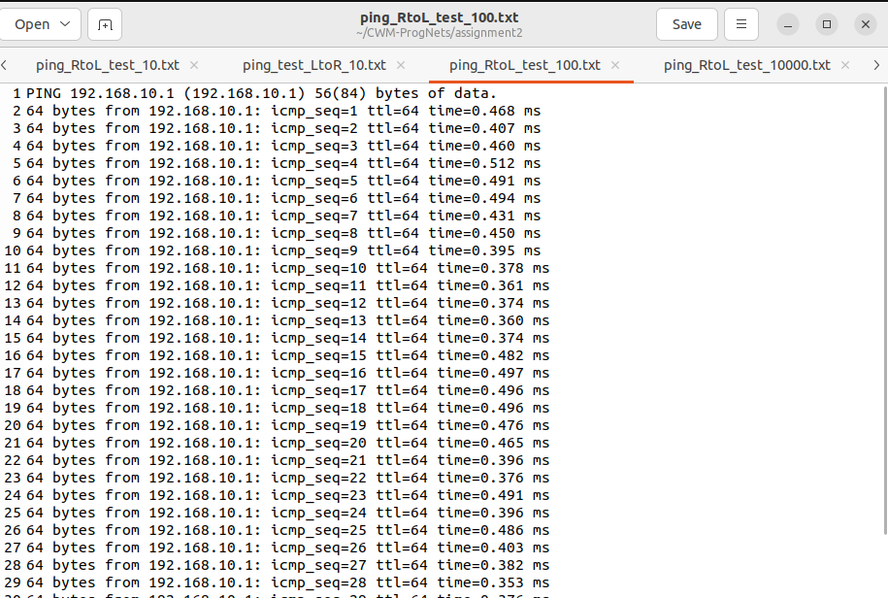
Figure 1. Result of running ping tests 100 times from the Raspberry Pi to the lab machine

rtt min/avg/max/mdev = 0.338/0.464/0.538/0.052 ms

The mean testing time is 0.464 ms with a standard deviation of 0.052ms. Since the sample size is quite large this time, the result we obtained should be more accurate compared to the previous one. Both the mean testing time and the standard deviation decreased compared to the previous test, which means the testing results are less separated and the generally quicker than the last test.

Test 4: 10000 times from the Raspberry Pi to the lab machine

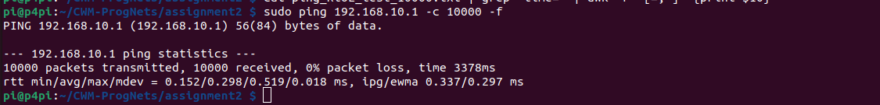
Figure 2. Result of running ping tests 10000 times from the Raspberry Pi to the lab machine

The sample size is too large to be shown on the screen. However, from the concluded data, we can see that the average time is significantly smaller as well as the standard deviation.

Test 5: Run measurements with 3 different intervals

5.1 interval = 0.01

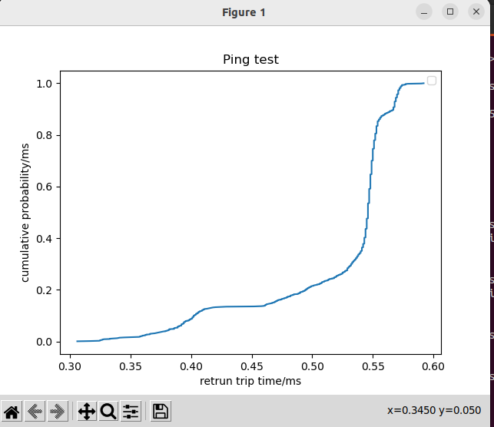
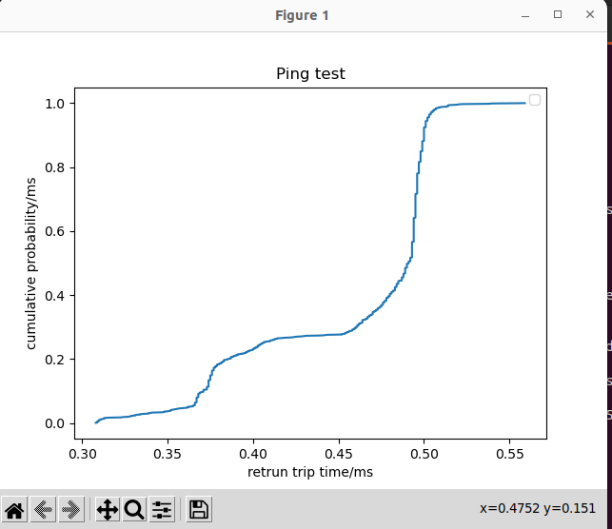

5.2 interval = 0.001

